

**UET Peshawar**

**Department Of Computer Science**

**Lab Task 06-Composition-in-java**

**Submitted By:**

Waqas Khan S/o Azeem Khan CSIT pwr Batch-24

RegNo : 24pwbcs1141

**Submitted To:**

Sir Syed Adeel Ali Shah Associate Professor CS&IT Peshawar

**Task for Students**

**Problem Statement**

Create a program that models a Smartphone using composition. The Smartphone class should have the following components:

1. **Screen**:
   * Attributes: size, resolution, type (e.g., AMOLED, LCD).
   * Methods: display(String content) to show content on the screen.
2. **Battery**:
   * Attributes: capacity (in mAh), percentage.
   * Methods: charge(int amount), use(int amount) to simulate battery usage and charging.
3. **Processor**:
   * Attributes: model, cores, clockSpeed (in GHz).
   * Methods: process(String task) to simulate processing a task.
4. **Camera**:
   * Attributes: resolution (in MP), type (e.g., wide, ultra-wide).
   * Methods: clickPicture().

**Guidelines:**

1. Define each component as a separate class with appropriate attributes and methods.
2. Create a Smartphone class that contains these components.
3. Write a main program to:
   * Create objects for each component.
   * Combine them to create a Smartphone.
   * Demonstrate the usage of each component.

**Expected Outcome**

Students will understand:

* How to model real-world objects using composition.
* The benefits of modular code design.
* How to create and use objects within other classes.

**Main.java Files**

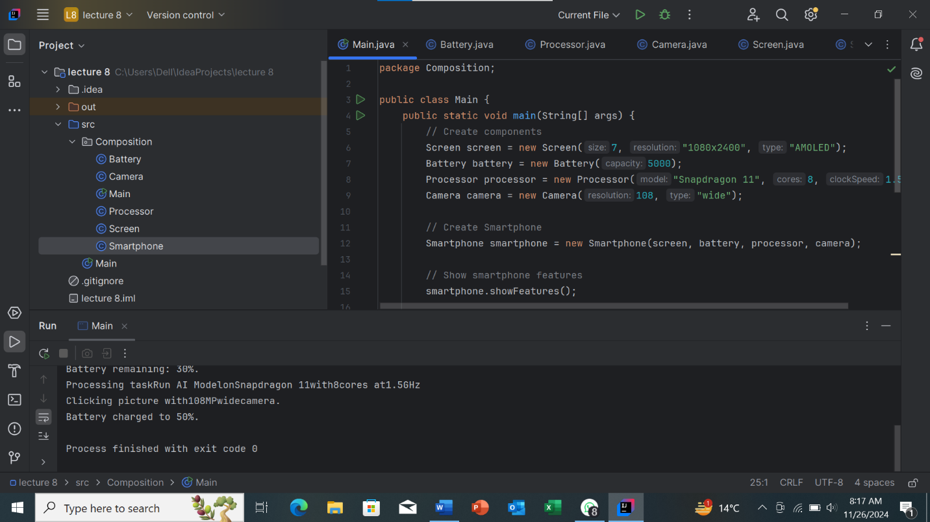

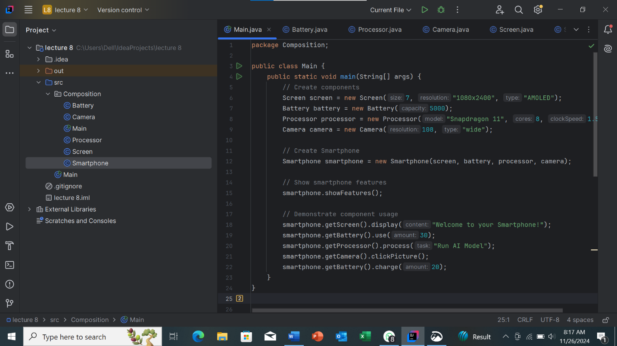

**SmartPhone.java Files**

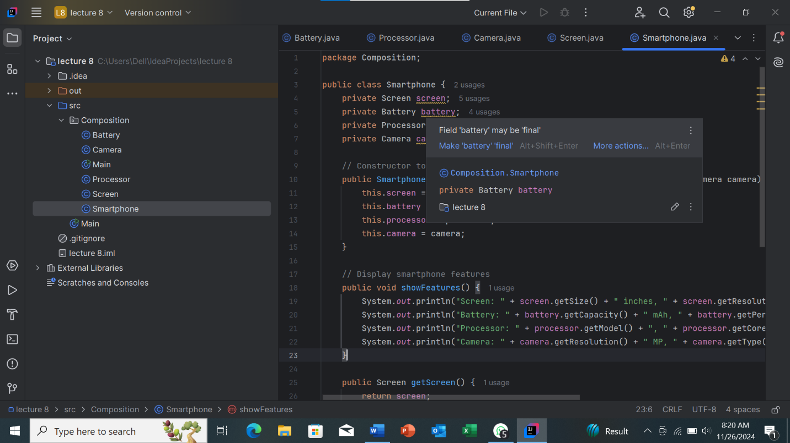

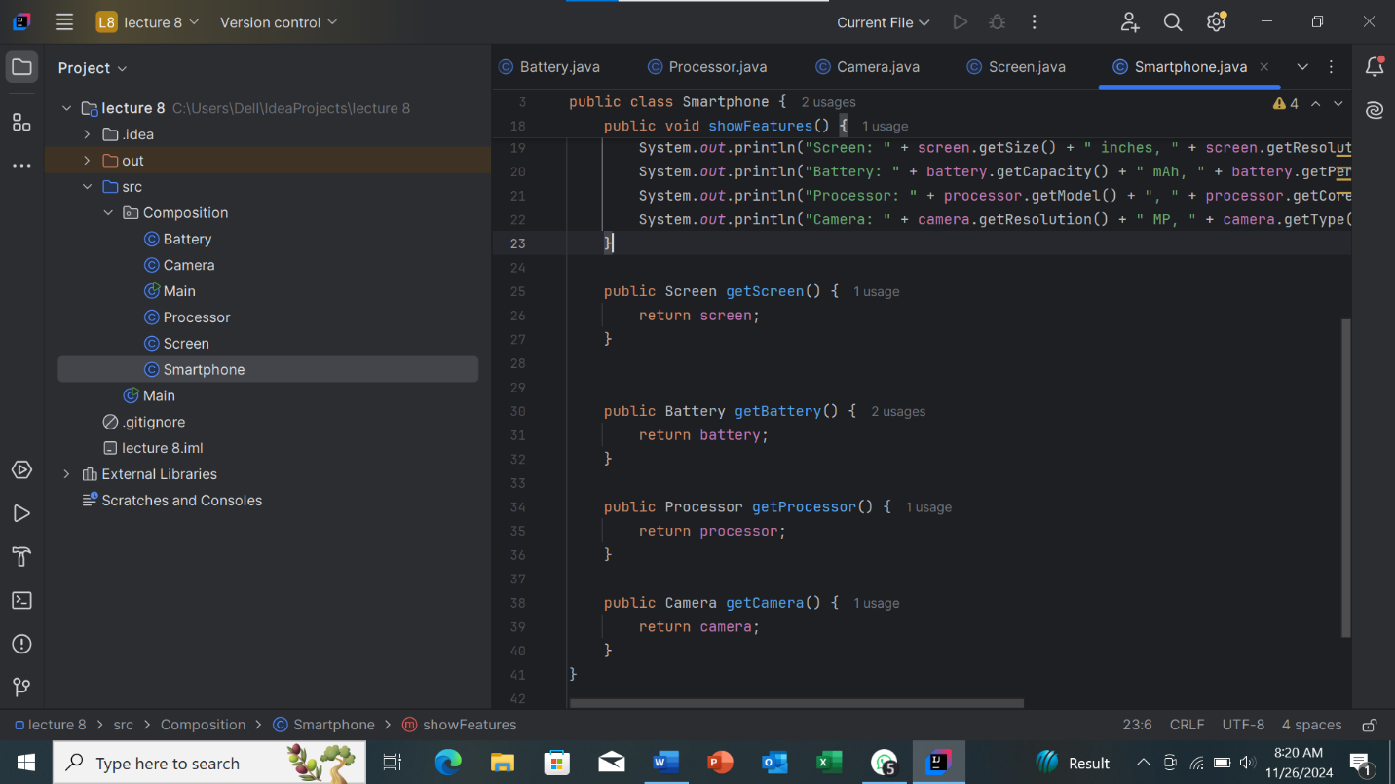

**Screen.java Files**

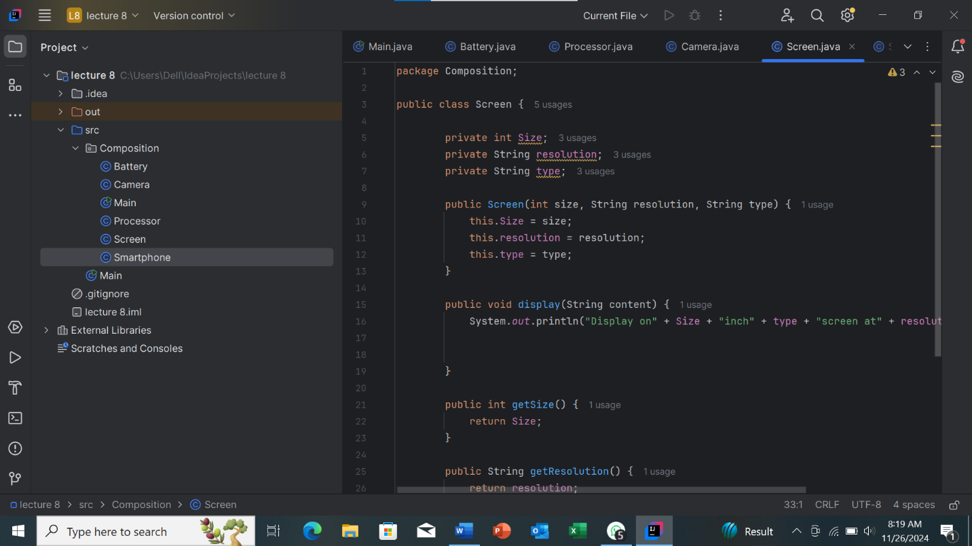

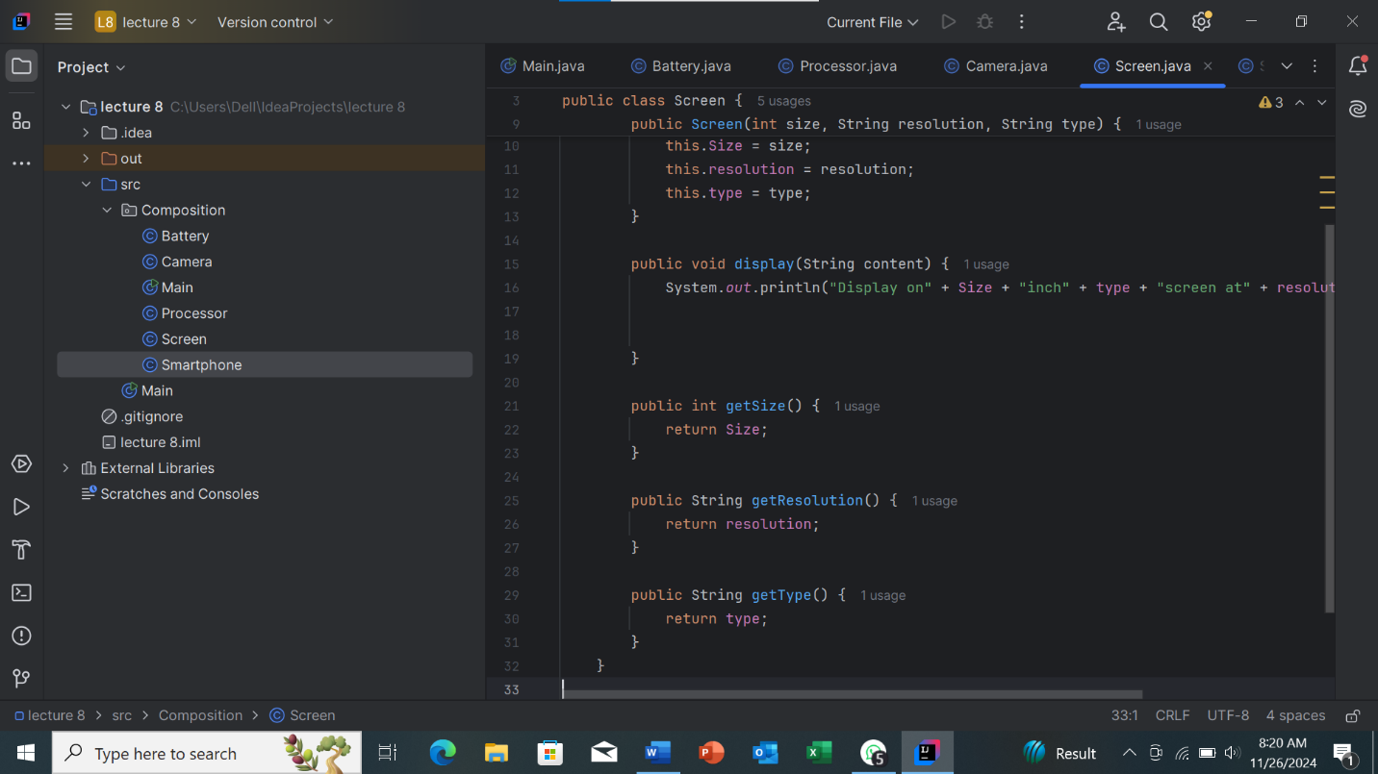

**Processor.java Files**

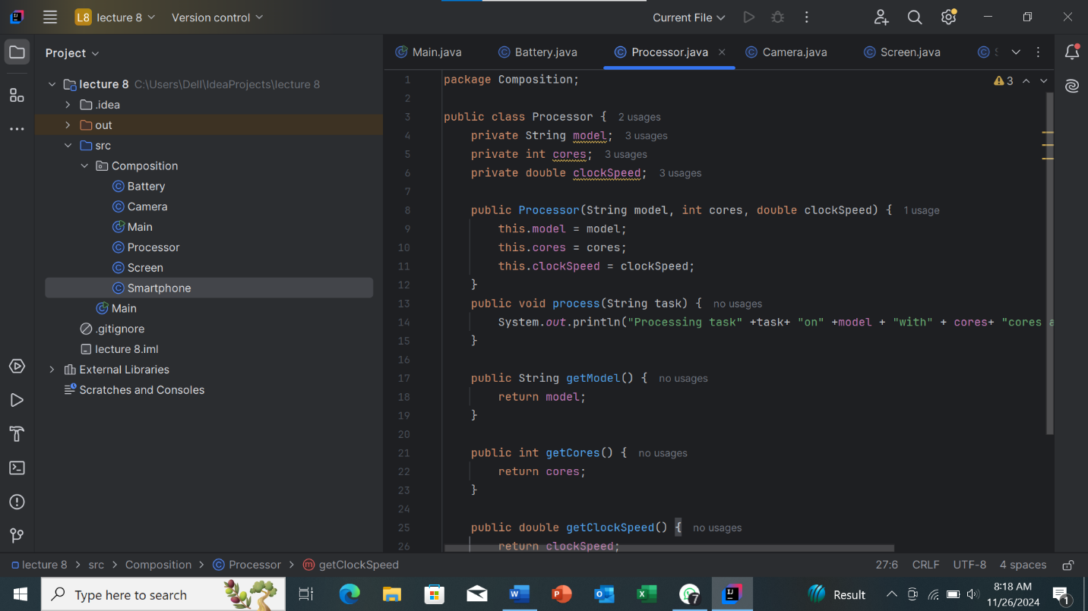

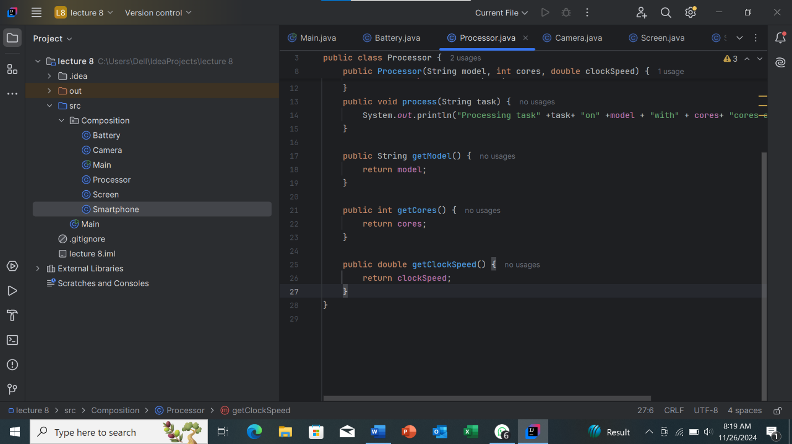

**Battery.java Files**

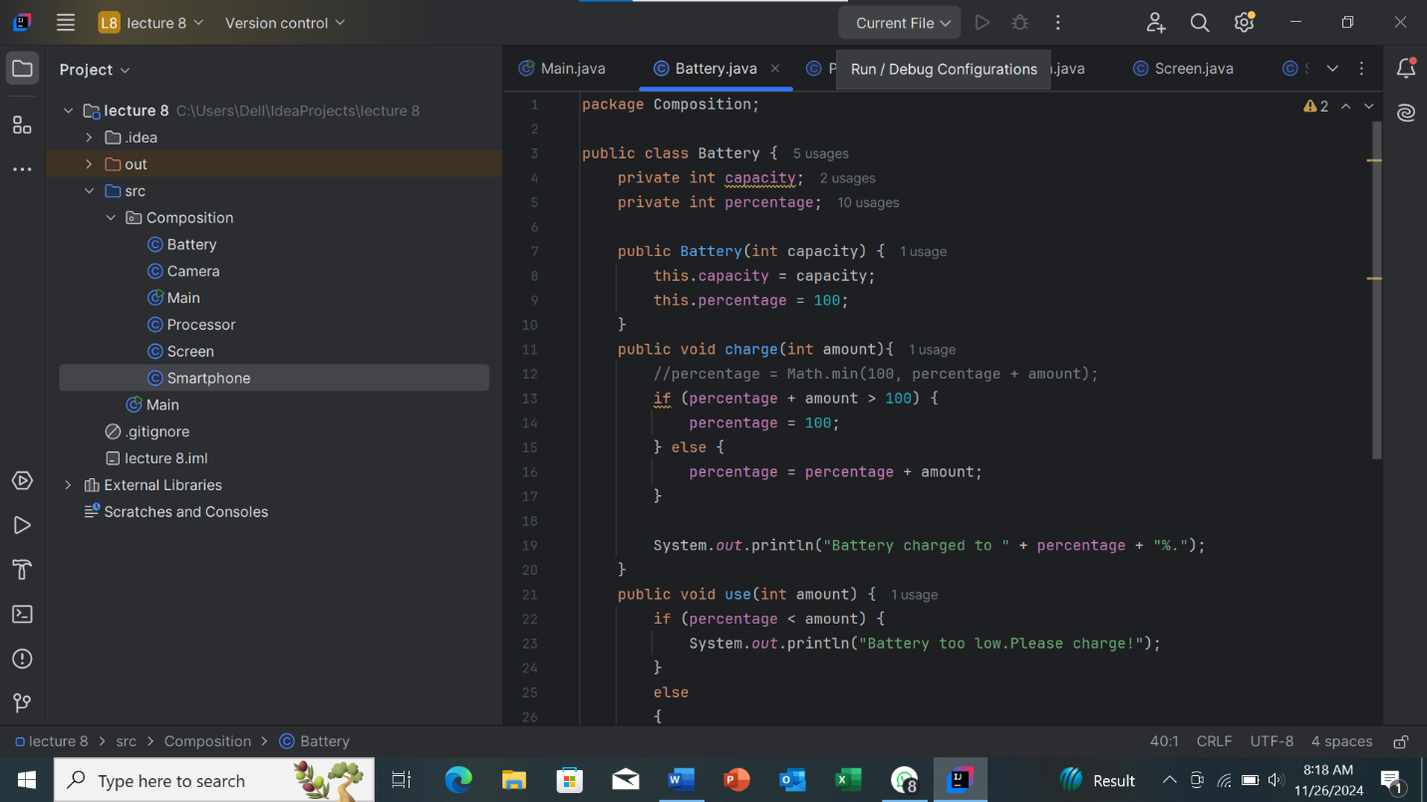

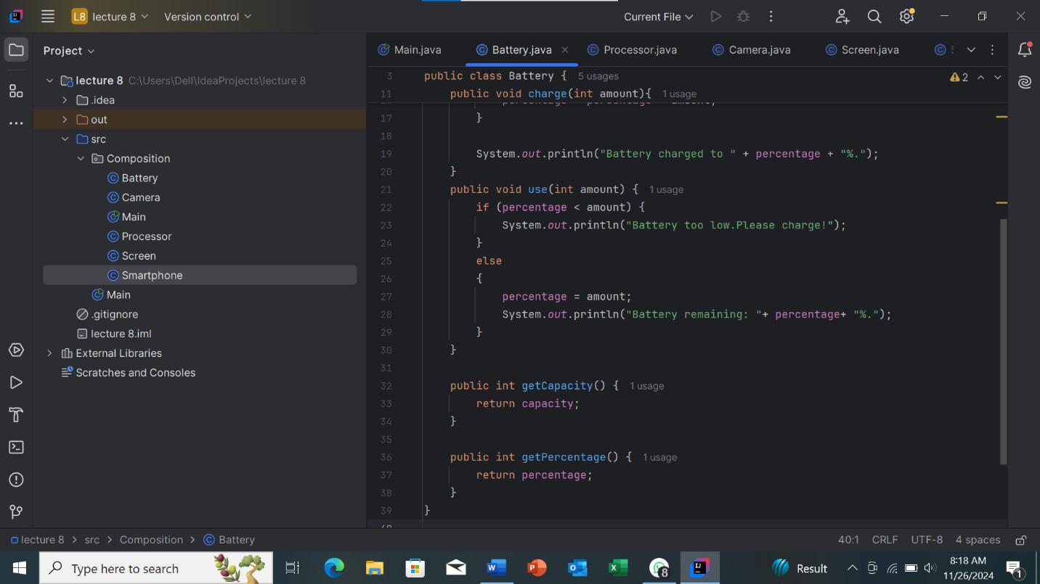

**Camra.java Files**

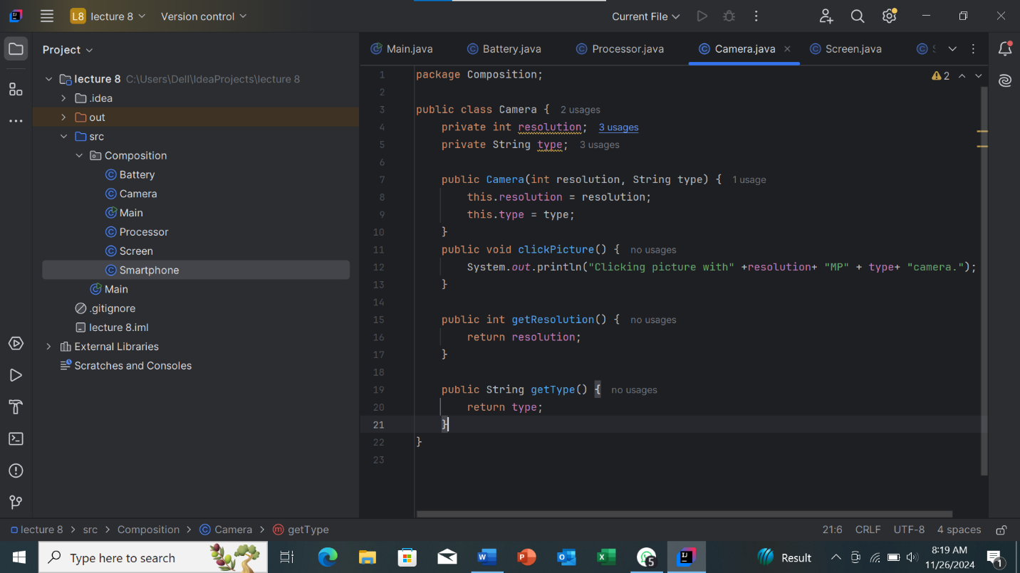

Thank You !..